

**Appendix 1 – Block Plan**

**18/03313/FUL – Land East of Cherwell School Southa**

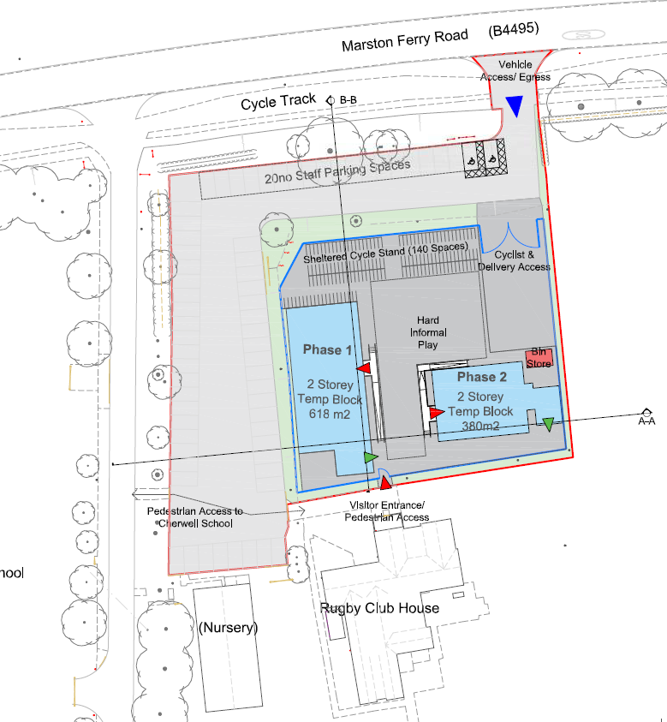

Cherwell School South Site

Playing Field